1. A delivery company wants to predict how long it will take to deliver a package. The company collects data about each delivery, including the distance traveled, the number of packages delivered on the same day, and the time the order was placed.

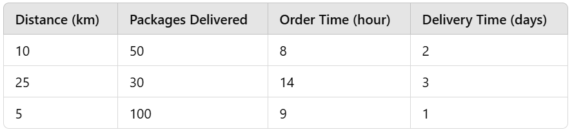

1. Which columns represent the inputs that affect delivery time?
2. Which column represents the value you want to predict?
3. In your opinion, which input is likely the most important in determining delivery time?
4. A restaurant wants to predict customer satisfaction ratings based on factors such as the wait time for food, the price of the meal, and the cleanliness score of the restaurant.

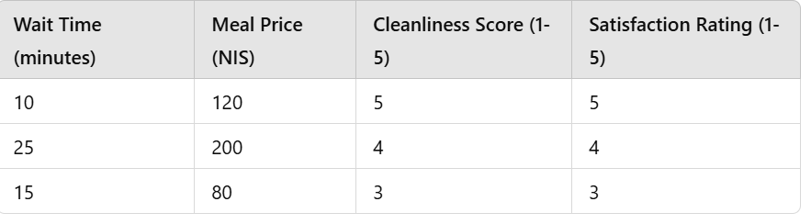

* 1. Which columns represent the factors that influence satisfaction?
  2. Which column represents the value the restaurant wants to predict?
  3. In your opinion, which factor is most likely to impact satisfaction?

1. An energy company wants to predict monthly energy usage for households based on the size of the house, the number of people living there, and the average monthly temperature.

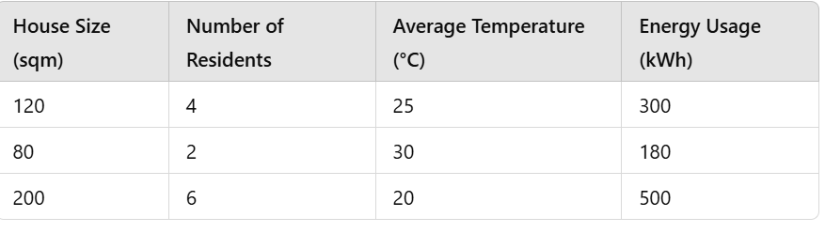

* 1. Which columns represent the inputs for predicting energy usage?
  2. Which column represents the value the energy company wants to forecast?
  3. Which input do you think has the strongest effect on energy usage?

1. **What is the purpose of linear regression?**  
   a) To classify data into categories.  
   b) To find a relationship between features and a continuous target.  
   c) To cluster similar data points together.  
   d) To predict future data trends.
2. :**Which of the following is an example of a target in a regression task?**  
   a) The color of a car.  
   b) The price of a house.  
   c) The type of fruit.  
   d) The name of a customer.
3. If you have time create a python function that gets 2 wieghts and 2 biases and returns a graph with the 2 respective lines. You can play with the numbers to see the effect of each. (default bias should be 0 , default weight should be 1)